44.34: From Eq. (44.15), 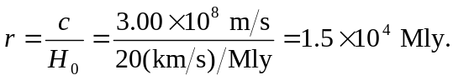 b) This distance represents looking back in time so far that the light has not been able to reach us.

